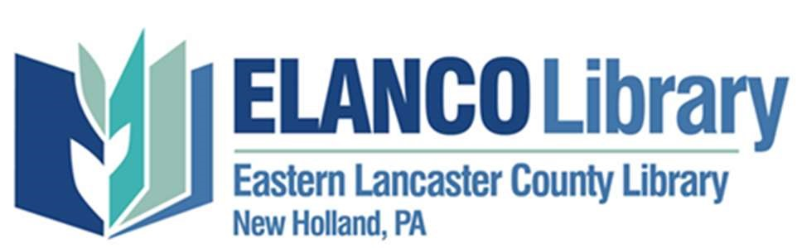
Board of Trustees
Regular Meeting Agenda

Date: Tuesday, October 19, 2021 – 7pm
Location: Microsoft Teams meeting
Join on your computer or mobile app: Click here to join the meeting
Or call in (audio only): +1 872-703-5418,,16769082# United States, Chicago Find a local number
Phone Conference ID: 167 690 82#
Call to Order

Welcome

Approval of Minutes of Previous Meeting
- Last Regular Meeting: September 21, 2021
Recurrent Monthly Items
- Increase Community Awareness of the ELANCO Library and what we offer
  - Introduction of Guests
  - Marketing, Fundraising & Special Events Committee (Josh(Chair), Sarah, Kendra, Susan)
  - Governance Committee (Jim(Chair),Mike, Lou Ann, Hallie)
    - Motion to approve EL-306, EL-307
- Ensure the overall sustainability of the library as a community resource
  - Municipality Committee (Lou Ann(chair), Jim, Hallie)
  - Treasurer’s Report – Mike Ireland
    - Motion to approve report
- Evaluate and adapt the materials, programs and services offered for the benefit of current and potential patrons
  - Programs & Services Committee (Kendra(chair), Sarah, Lee)
  - District Council Report – Lori
- Improve the Customer Experience, ensuring the ELANCO Library is a friendly, welcoming and community-centered organization
  - Management Committee (Mark(Chair), Mike, Hallie, Lee, Lori)
    - Report on Onboarding of director
    - Motion to offer Director 2 weeks of vacation as exemption to policy EL-204
- Evaluate the culture of the workplace environment to determine ways to improve our employees’ satisfaction
  - Ad Interim Director’s Report – Carla Barrows

New Business
- Assistant Director Search
Housekeeping
- Correspondence Needed:

Adjourn

Next Meeting
November 16, 2021 @ 7pm (Teams meeting)
December 21, 2021 @ 7pm (Teams meeting)

Strategic Plan Objectives
1. Increase Community Awareness of the ELANCO Library and what we offer
a. Develop a strategic marketing plan
b. Community outreach that builds awareness
c. Empower employees to be ambassadors for the ELANCO Library
2. Ensure the overall sustainability of the library as a community resource
a. Sustainable funding Initiatives
Public Funding
i. Work with our five municipalities to establish a uniform per capita funding formula that provides a fixed portion of the library’s operating budget.
ii. Develop a planned approach to educate our state legislators about the vital role stable state funding plays in the operation of local libraries.
Private Funding
iii. Seek Grants.
iv. Build upon the fundraising campaigns.
v. Continue to develop and execute effective fundraising events.
vi. Build the Endowment Fund.
b. Sustainable Governance Initiatives
i. Develop a Trustee recruiting plan that identifies potential future trustees and prepares them for board service.
ii. Work with our five municipalities to enact a plan whereby each of the municipalities appoint board members to represent their municipalities.
c. Sustainable operational practices initiatives
i. Develop a Facilities Plan that addresses the long-term maintenance needs of the library building.
ii. Within the Facilities Plan, address the issues of energy efficiency, water usage efficiency, indoor air quality, and sustainable materials and supplies usage.
3. Evaluate and adapt the materials, programs and services offered for the benefit of current and potential patrons
a. Materials – Meet or exceed state minimum spending on collection development.
b. Programs & Services – Plan programs and services around the following five literacies: (As described in the PA Forward initiative.)
i. Basic Literacy – The ability to read, write and communicate.
ii. Information Literacy – The ability to use online resources and current technology.
iii. Civic and Social Literacy – The ability to participate and contribute effectively to community, government and society.
iv. Health Literacy – The ability to manage personal well-being and partner effectively with healthcare providers.
v. Financial Literacy – The ability to manage personal finances and to be an informed consumer.
4. Improve the Customer Experience, ensuring the ELANCO Library is a friendly, welcoming and community-centered organization
a. Evaluate the physical layout of the library building to identify potential changes that would make the space more appealing to library users.
b. Develop a Community Outreach Plan that creates a systematic approach to connecting with and communicating with community business organizations.
c. Establish an ongoing customer service training program for staff and volunteers.
d. Train staff on core competencies.
5. Evaluate the culture of the workplace environment to determine ways to improve our employees’ satisfaction

